### **Project 01**

### **Deploying a Node.js App Using Minikube Kubernetes**

#### **Overview**

This project guides you through deploying a Node.js application using Minikube Kubernetes. You'll use Git for version control, explore branching and fast-forward merges, and set up Kubernetes services and deployment pods, including ClusterIP and NodePort service types.

#### **Prerequisites**

* Minikube installed
* kubectl installed
* Git installed
* Node.js installed ([https://nodejs.org/en/download/package-manager/all#debian-and-ubuntu-based-linux-distributions](https://nodejs.org/en/download/package-manager/all" \l "debian-and-ubuntu-based-linux-distributions))

#### **Project Steps**

### **1. Set Up Git Version Control**

**1.1. Initialize a Git Repository**

**1.2. Create a Node.js Application**

**1.3. Commit the Initial Code**

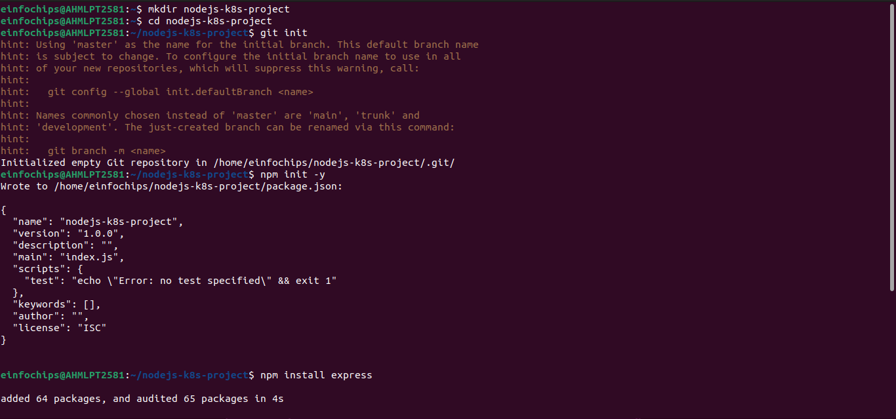

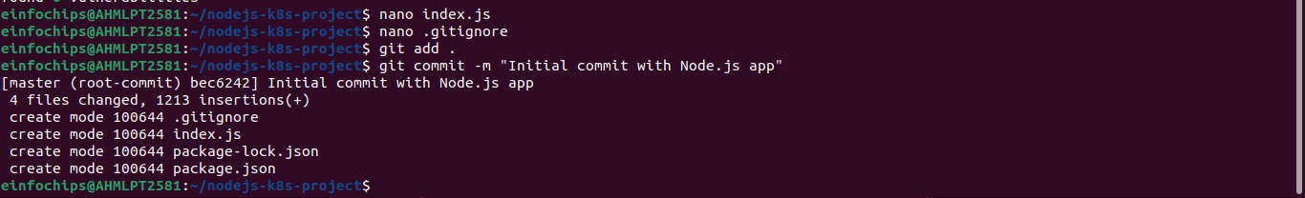

### **2. Branching and Fast-Forward Merge**

**2.1. Create a New Branch**

**2.2. Implement a New Route**

**2.3. Merge the Branch Using Fast-Forwar**

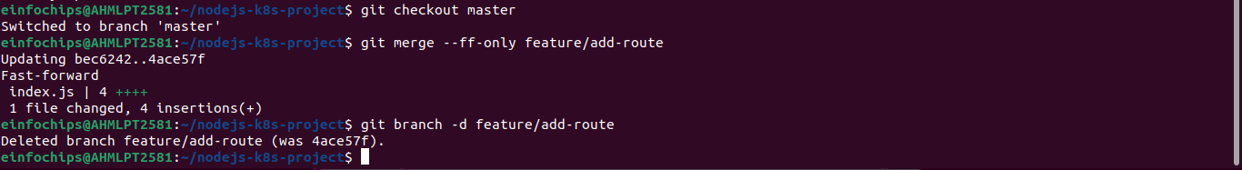

### **3. Containerize the Node.js Application**

**3.1. Create a Dockerfile**

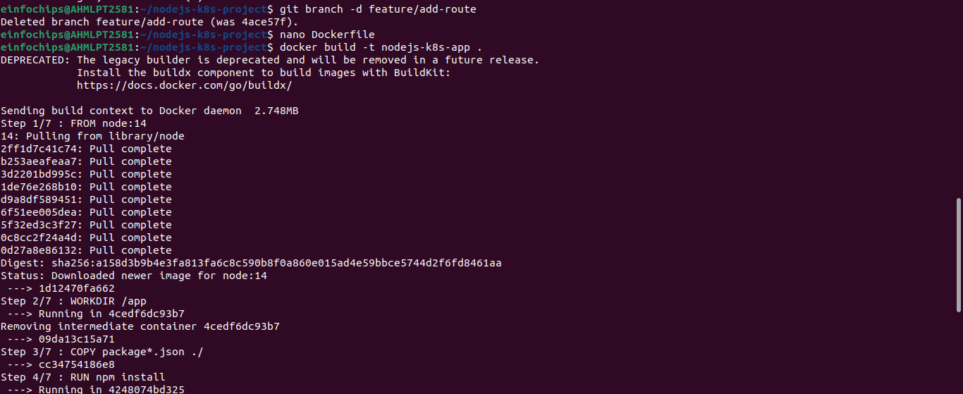

**3.2. Build and Test the Docker Image**



### **4. Deploying to Minikube Kubernetes**

**4.1. Start Minikube**

**4.2. Create Kubernetes Deployment and Service Manifests**

**4.3. Apply Manifests to Minikube**

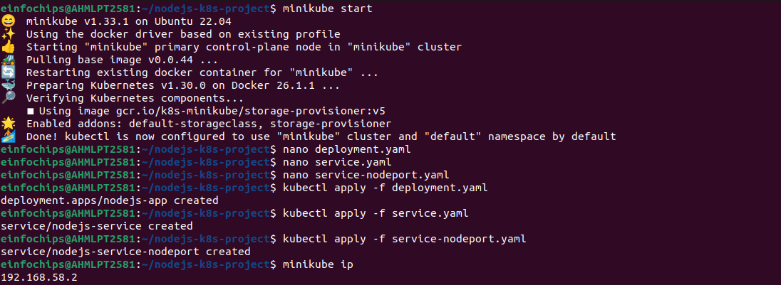**4.4. Access the Application**

### **Making Changes to the App and Redeploying Using Kubernetes**

### **6. Making Changes to the Node.js Application**

**6.1. Create a New Branch for Changes**

**6.2. Update the Application**

**6.3. Commit the Changes**

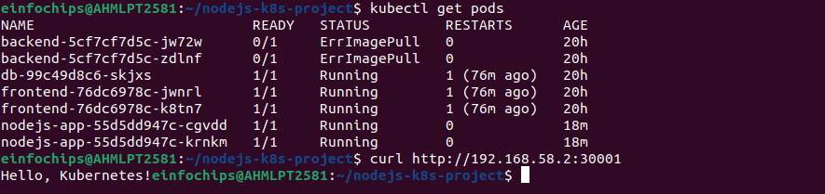

### **7. Merge the Changes and Rebuild the Docker Image**

**7.1. Merge the Feature Branch**

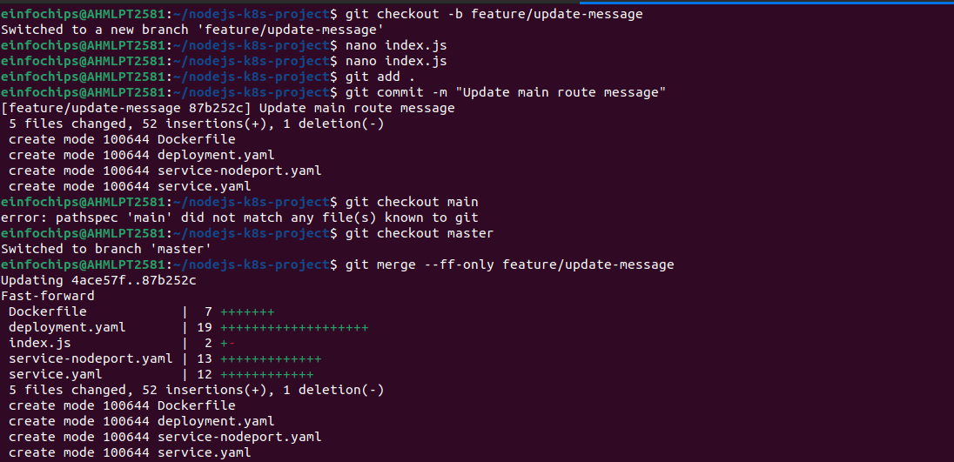

**7.2. Rebuild the Docker Image**

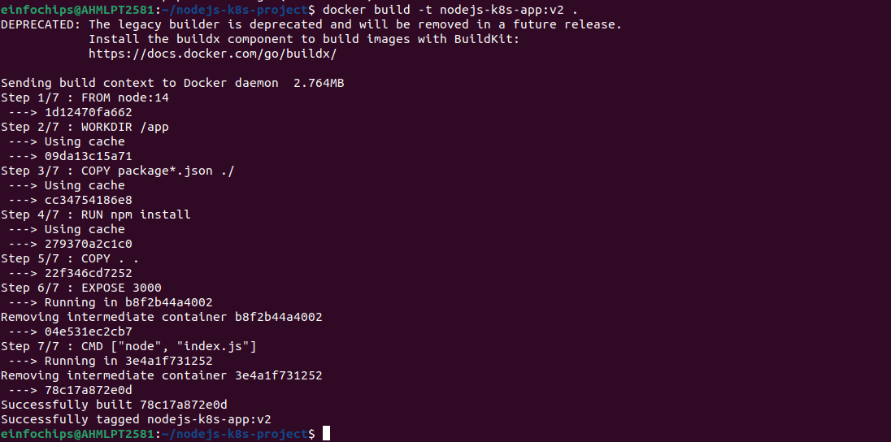

### **8. Update Kubernetes Deployment**

**8.1. Update the Deployment Manifest**

**8.2. Apply the Updated Manifest**

**8.3. Verify the Update**

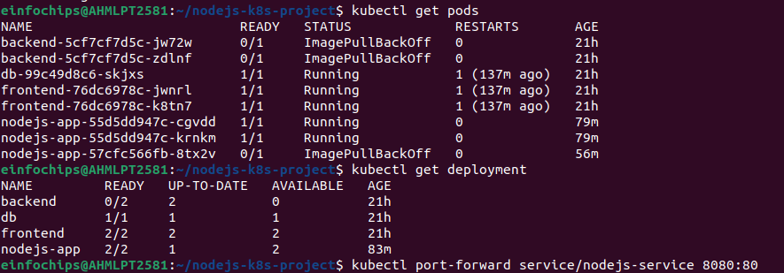

### **9. Access the Updated Application**

**9.1. Access Through ClusterIP Service**

**9.2. Access Through NodePort Service**



**Project 02**

### **Deploying a Python Flask App Using Minikube Kubernetes**

#### **Overview**

This project guides you through deploying a Python Flask application using Minikube Kubernetes. You'll use Git for version control, explore branching and fast-forward merges, and set up Kubernetes services and deployment pods, including ClusterIP and NodePort service types.

#### **Prerequisites**

* Minikube installed
* kubectl installed
* Git installed
* Python installed

#### **Project Steps**

### **1. Set Up Git Version Control**

**1.1. Initialize a Git Repository**

**1.2. Create a Python Flask Application**

**1.3. Commit the Initial Code**

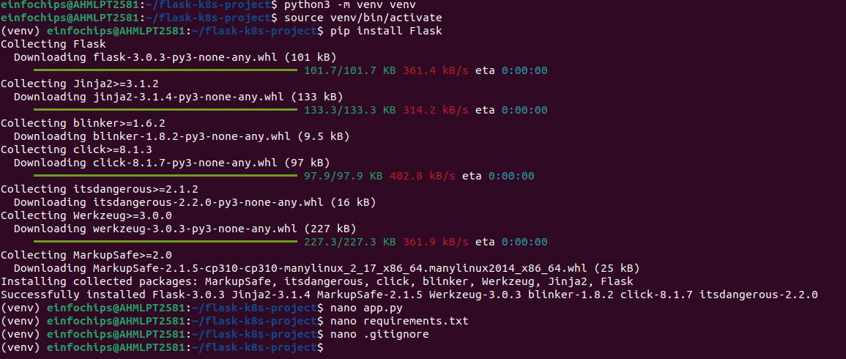

### **2. Branching and Fast-Forward Merge**

**2.1. Create a New Branch**

**2.2. Implement a New Route**

**2.3. Merge the Branch Using Fast-Forward**

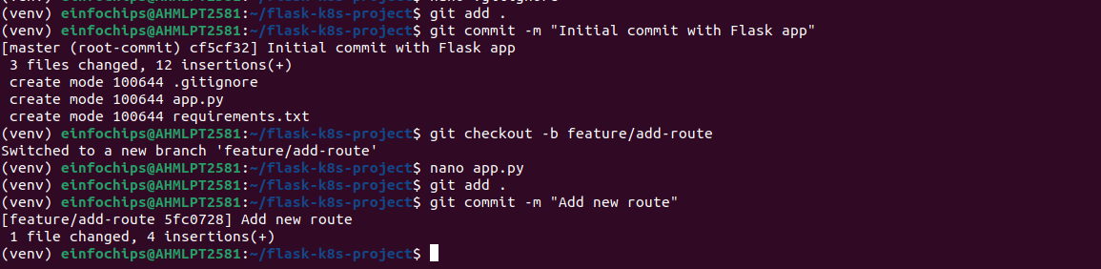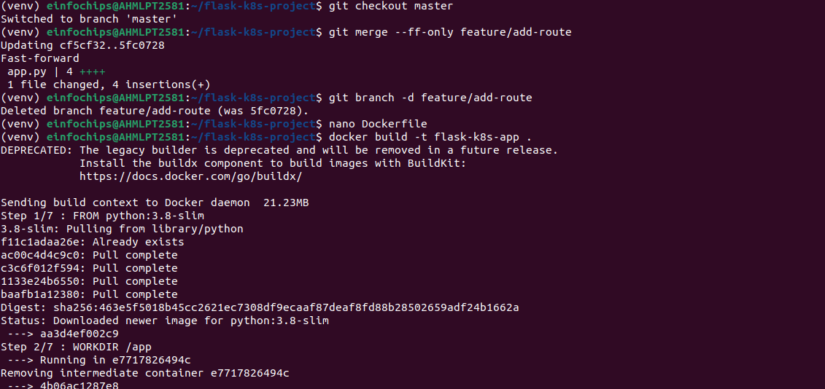

### **3. Containerize the Flask Application**

**3.1. Create a Dockerfile**

**3.2. Build and Test the Docker Image**

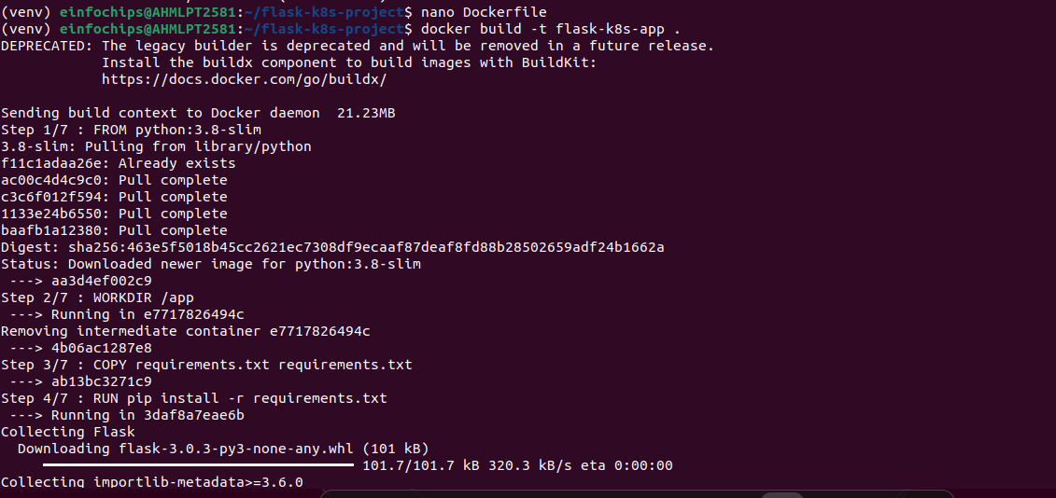

### **4. Deploying to Minikube Kubernetes**

**4.1. Start Minikube**

**4.2. Create Kubernetes Deployment and Service Manifests**

